**ONLINE PIZZA ORDERING SYSTEM**

***Project Report***

**in**

(Web Programming lab)

### ***Submitted in partial fulfillment for the Learning Objectives of Outcome Based Education***

**Paradigm in**

**(III Sem. B.E., COMPUTER SCIENCE AND ENGINEERING)**

By,

#### SUHAIL BANKAPUR ( 2GI17CS142 )

#### YASH JAVALKAR ( 2GI17CS171 )

#### VISHNU JOSHI ( 2GI17CS168 )

**Under the guidance of**

**Prof. Vidyadheesh J.Pandurangi**

**Assistant Professor**



KLS Gogte Institute of Technology, Belgaum

### Department of Computer Science and Engineering

### **Udyambag, Belgaum - 590008, Karnataka**

**Academic Year 2018-2019**

**CERTIFICATE**

ROLL NO.__________ SEAT NO.________________

Karnataka Law Society’s

GOGTE INSTITUTE OF TECHNOLOGY

Department of Computer Science and Engineering

Udyambag Belagavi -590008

Karnataka, India.



*This is to certify that the Seminar entitled “Educational site” is a bona fide record of the Seminar work done by* ***Suhail Bankapur*** *(2GI17CS142),* ***Yash javalkar*** *(2GI17CS171) and* ***Vishnu Joshi*** *(2GI17CS168) under my supervision and guidance, in partial fulfillment of the requirements for the Outcome Based Education Paradigm in Computer science and Engineering from Gogte Institute of Technology Calicut for the academic year 2018-19*

**Veena V.Desai**

*Professor & Head*

*Dept. of computer science and Engineering*

Place: KLS Gogte Institute of Technology Belgaum.

Date:

**ACKNOLEDGEMENT**

This group feels greatly indebted to Computer Science and Engineering Department, for the opportunity given us to undertake this “Online Pizza Ordering System” project. This project includes thoughts and contribution of many individuals. And we wish to express our sincere appreciation and gratitude to them.

First and foremost we want to extend entirely our gratitude to our lecturer for sharing his knowledge and profound wisdom with us. We appreciate all his comments and suggestions, which are incorporated into this project.

We would also like to express our gratitude towards and group members. Without their help, support, and encouragement, this project would never had been completed.

In our respect, this project is an outcome of the learning

Experience we have shared with our fellow students. We dedicate this project to all our fellow engineering students.

-**Suhail, Yash, Vishnu**

**ABSTRACT**

One primary aim of this project is to develop an online pizza odering system. The platform should allow the customer to login the system, order the pizza, customize it and pay online. . The major advantage is that, the entire things process is real-time and online, which means the customer can order the pizza from anywhere (e.g. at home). This site gives the customer to order and pay online without any problem. This site gives user to customize according to personal preferences or specifications. This project makes use of concepts of HTML, CSS, javascript and many more. It gives chance to the user to navigate according to their convenience.

**CONTENTS**

**Sl.No. TITLE Page no.**

----------------------------------------------------------------------------------------------------------------------------------------

1. INTRODUCTION 1-2

1.1 Domain details/ Motivation for taking up the project

1.2 Project Objectives and Goal

2. PROBLEM DEFINATION 3

2.1 Problem Statement

2.2 Hardware and software requirement.

3. IMPLEMENTATION 4-7

3.1 Methodology

3.1.1 Snapshot/Photograph

4. OUTCOMES ACHIEVED 8

5. CONCLUSION 8

6. REFRENCES 9

**INTRODUCTION**

This is Online Pizza Ordering System site which has various types of pizzas with various types of toppings. This site helps the customers to get delivered pizza to their location. The website has been developed in HTML, CSS and JavaScript. HTML is a markup language which is in reality a backbone of any site, every site can’t structured without the knowledge of html. If we make our web page only with the help of html, than we can’t add many of the effective features in a web page, for making a web page more effective we use various platforms such as CSS. So here we are using these entire features to make our web pages more effective as well as efficient and to make our web pages dynamic .

**1.1 MOTIVATION FOR TAKING UP THIS PROJECT**

The whole world is in love with pizzas. The billions of dollars earned by different pizzerias across the globe just prove this. The love of pizzas has enabled the rise of large pizza companies like Pizza Hut, Domino’s, Papa John’s and much more.

As the internet users are increasing exponentially, these companies have introduced Online Pizza ordering system for taking orders from customers. This system not only improves customer’s experience but also eases the workload on the staff of pizzerias.

**1.2 PROJECT OBJECTIVES AND GOAL**

The main objective of the project is to create an online pizza ordering site which meets the user requirement so that the user can buy a pizza while customizing it and without going to the shop. This helps the user to order pizza sitting at home. The scope of the project is not only limited to a particular pizza but to add toppings or alter according to personal preferences or specifications.

**OBJECTIVES**

The main objectives of this project are,

1. To implement the fundamentals of World Wide Web.
2. To develop application using HTML, CSS and JavaScript.
3. It overcomes all the problems of existing system.
4. Pizza can be order in way that is more convenient.

**PROBLEM DEFINATION**

**2.1 PROBLEM STATEMENT**

To develop a web-based application which enables customers to order their pizzas online for home delivery.

## **2.2 SOFTWARE AND HARDWARE REQUIREMENT**

* Windows 7 or higher.
* Notepad++
* Processor – i3
* Hard Disk – 5 GB
* Memory – 4GB RAM
* Internet Connection

**IMPLEMENTATION**

**3.1 METHODOLOGY**

* In this system, while accessing for the first time, customer needs to register themselves by filling up basic registration details.
* Once the registration is successful, customer need to login with a valid username and password for secure login.
* After successful log in, customer will see the homepage where various types of pizzas will be listed with their image.
* The menu will be visible to the customer with the pizzas.
* All the ingredients will be shown with their prices. After selecting a desired pizza, customers can view the details of pizza such as price and category.
* Customer can specify the extra toppings (if required) and enter the quantity required and add a pizza to cart.
* Customer can directly click on buy now to place an order.
* Now payment option is shown to the customer.

**3.1.1 SNAPSHOTS**

LOGIN PAGE:

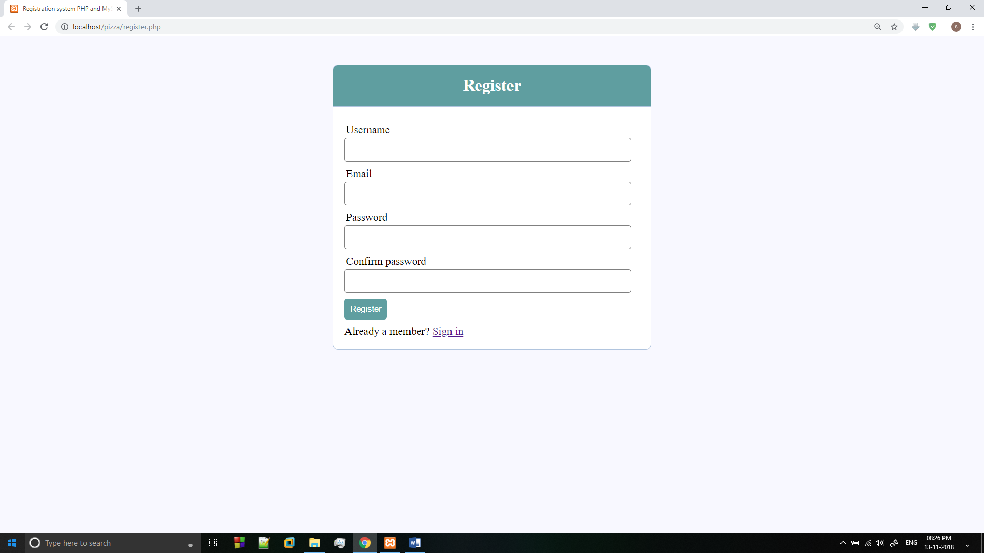

LOGOUT PAGE:

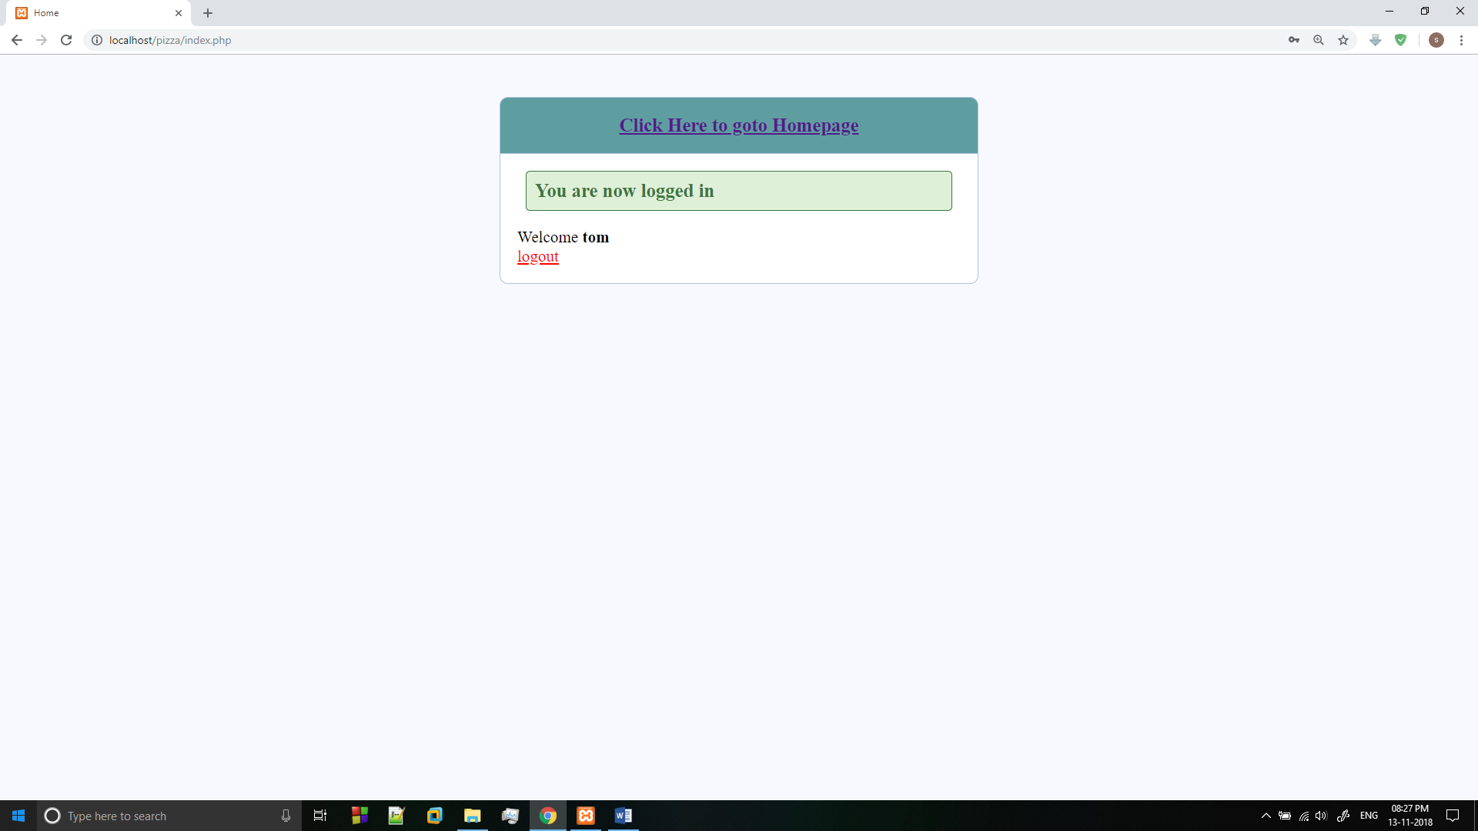

HOME PAGE:

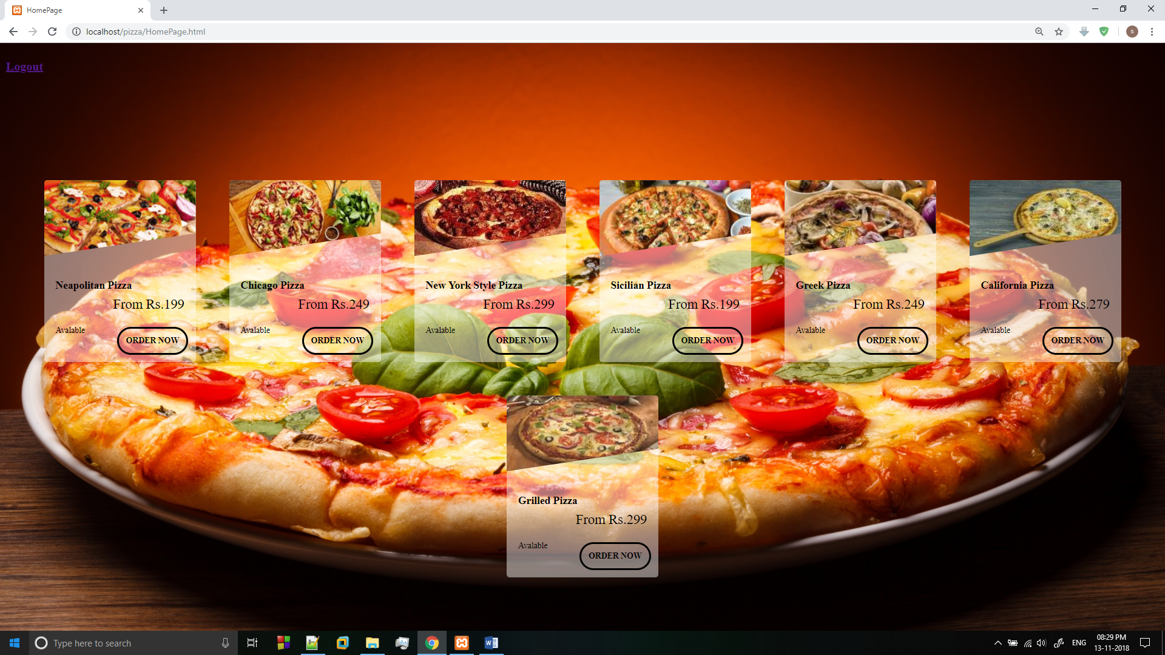

PIZZA DETAILS PAGE:

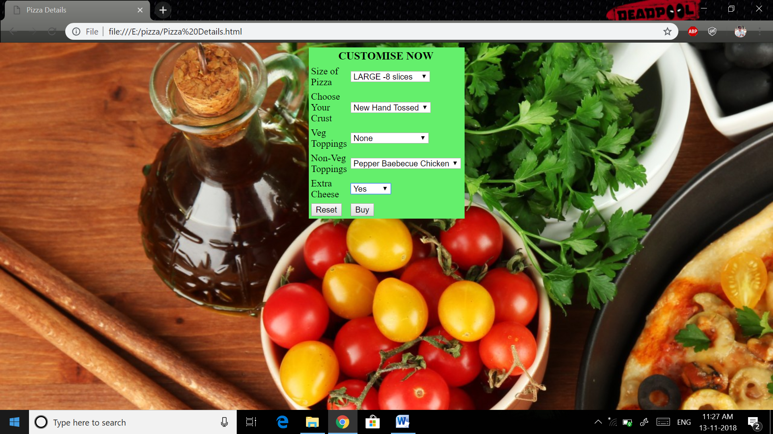

PAYMENT PAGE:

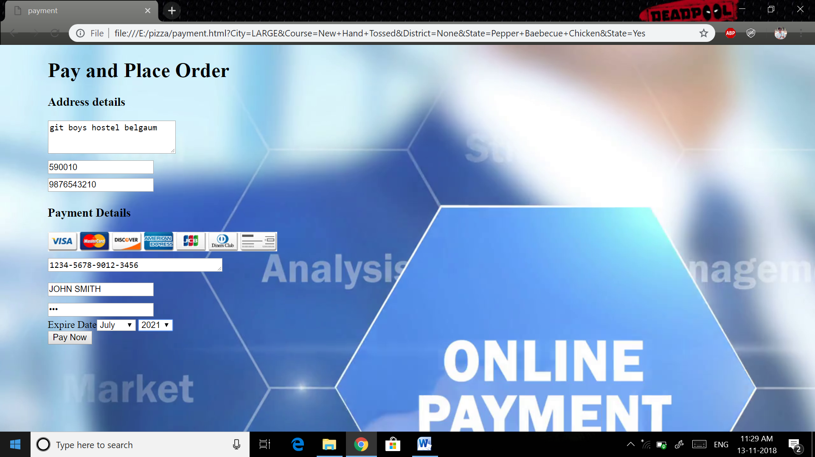

THANKYOU PAGE:

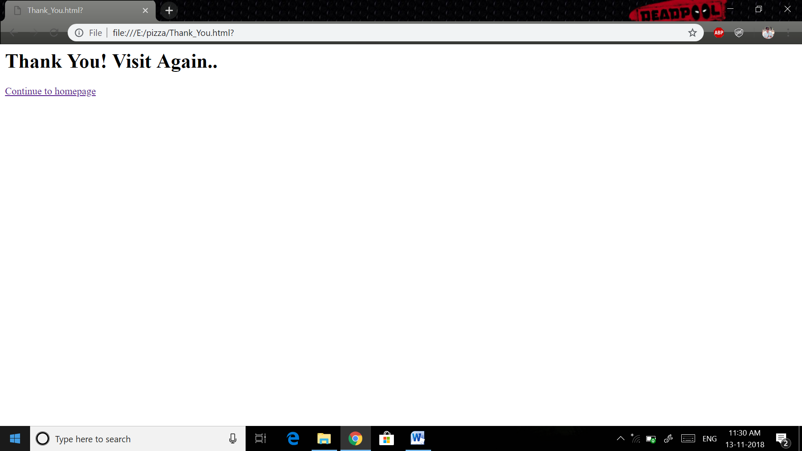

**OUTCOMES ACHIEVED**

* **Build your own pizza** – This system will help customers in ordering custom pizzas. So the customer will pick exactly the things which he/she wants in their pizza. This will surely enhance the image of the pizzeria and customer satisfaction will be more.
* **Online Payment**- This system will give the option to the customer for online payment. This will make pizza buying experience cash free.
* **Better Knowledge**- This system will provide customer all the details of his order before making the order.
* **Reduce Paper Work**- As most of the things will be performed online, it will reduce the usage of paper for the pizzeria.
* **Improves Efficiency**- This system will make things easier for staff as whole ordering process is done by the customer only. These were the objectives of the online pizza ordering System.

**CONCLUSION**

## In general, this project has been successfully carried out and satisfies the overall aim and objectives of the project.

## This system can be applied in pizza stores. This was all about online pizza ordering system. You know the importance of this system in our day-to-day lives as we all prefer online ordering over ordering on phone. All these modules can be implemented in the web application.

**REFERENCES**

* Jennifer Niederst Robbins, Learning Web design: A beginners guide to HTML, CSS, Javascript, and Web Graphics, O’reilly, 4thEdition and onwards.
* Robert W.Sebesta,Programming the World Wide Web, Pearson Education, 4th Edition and onwards.